## ***COSC344 Assignment 2***

Team **1**

Leader **Sam Fleury**

Members: **Sam Fleury**, **Tomofumi Kimura**, **Daniel Davidson, Brock Fairweather**

**1. Revised ER Diagram**

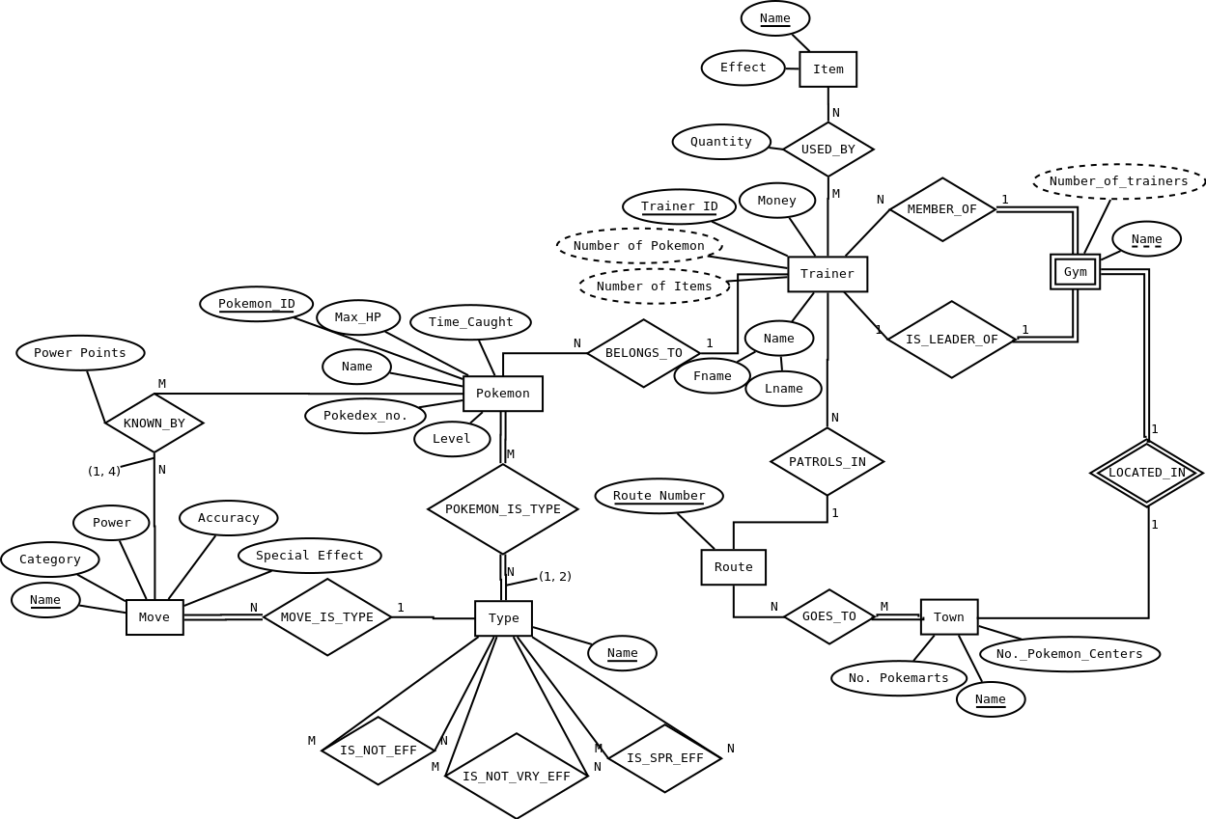

* Added (Min, Max) notation to relationships with limits.
* Move is now total participation in MOVE_IS_TYPE
* Time Caught is no longer a composite value

**2. Relational Schema**

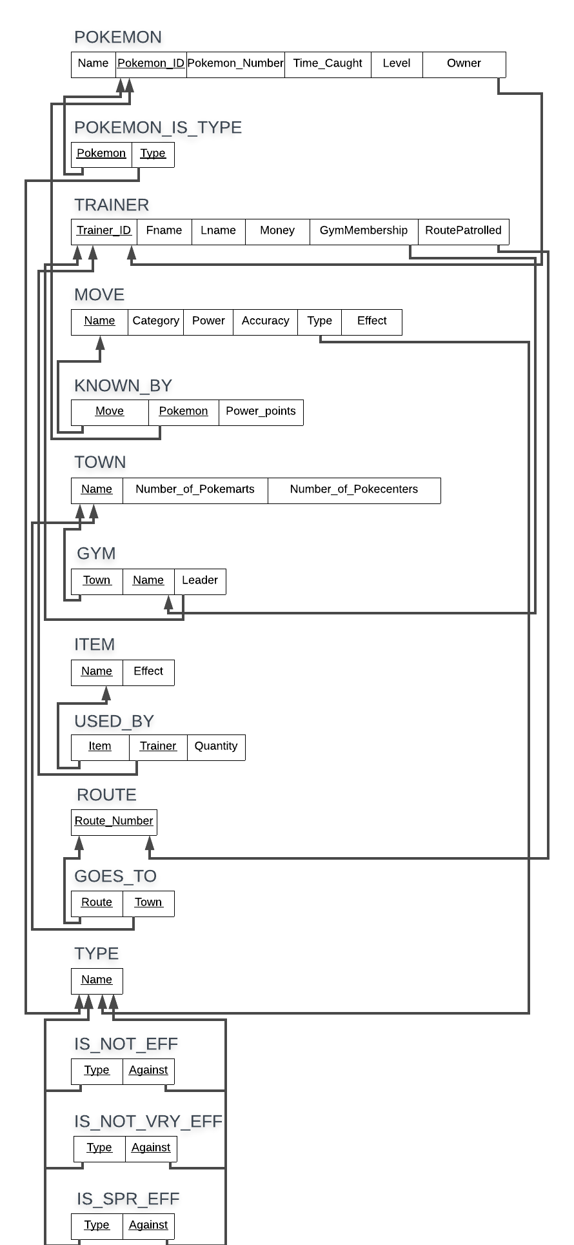

**3. Normalization**

**Trainer:**

Step 1 - 1NF: TRAINER is already 1NF because all their attributes are atomic.

Step 2 - 2NF: TRAINER is already in 2NF because they are in 1NF and all their non-prime attributes are fully functionally dependent on the primary key.

Step 3 - 3NF: TRAINER is already in 3NF format because they are in the 2NF and do not have Transitive Dependency.

Step 4 - BCNF: TRAINER is already in BCNF format because it is in 3NF and Trainer ID is a super key.

**Gym**:

Step 1 - 1NF: GYM is already 1NF because its attribute are atomic.

Step 2 - 2NF: GYM is already in 2NF because they are in 1NF and all their non-prime attributes are fully functionally dependent on the primary key.

Step 3 - 3NF: GYM is already in 3NF format because they are in the 2NF and do not have Transitive Dependency.

Step 4 - BCNF: GYM is already in BCNF because they are in 3NF and the only dependencies that exist are dependent on super keys.

**Town:**

Step 1 - 1NF: TOWN is already in 1NF because all its values are atomic.

Step 2 - 2NF: TOWN is already 2NF because every attribute is fully functionally dependent on primary key Town Name there are no partial functional dependencies.

Step 3 - 3NF: TOWN is already 3NF because there are no transitive dependencies.

Step 4 - BCNF: TOWN is already BCNF because every other attribute depends on Town Name, which is a super key.

**Type:**

(Note: When it came time to implement this, we discovered that “TYPE” is a reserved word in Oracle, so we have implemented this as “PTYPE”.)

Step 1 - 1NF: Type is already 1NF because it has only one attribute, which is atomic.

Step 2 - 2NF: Type has only one attribute, its primary key, and therefore nothing that doesn't fully depend on it.

Step 3 - 3NF: Again, having only one attribute means that Type can not possibly have any transitive dependencies.

Step 4 - BCNF: Type is 3NF and its only key is its superkey, therefore it is BCNF.

**Pokemon:**

(Note: Max-HP is a derived value of Level and Pokedex_no, so has been left off our relational schema. Also, Time_caught has been collapsed down into just time caught, as the DATE type includes both date and time as an atomic value.)

Step 1 - 1NF: Pokemon is already in 1NF because all its values are atomic.

Step 2 - 2NF: Pokemon is already 2NF because every attribute is fully functionally dependent on primary key Pokemon_ID; there are no partial functional dependencies.

Step 3 - 3NF: Pokemon is already 3NF because there are no transitive dependencies.

Step 4 - BCNF: Pokemon is already BCNF because every other attribute depends on Pokemon_ID, which is a candidate key.

**Route:**

Step 1 - 1NF: Route is already 1NF because it has only one attribute, which is atomic.

Step 2 - 2NF: Route has only one attribute, its primary key Route_Number, and therefore nothing that doesn't fully depend on it.

Step 3 - 3NF: Again, having only one attribute means that there can't be any transitive dependencies within Route.

Step 4 - BCNF: Route is 3NF and its only key is its superkey, so it is BCNF.

**Item:**

Step 1 - 1NF: Multi-valued attribute 'Effect' removed from ITEM and made into a new relation: ITEM_EFFECT.

ITEM (name)

ITEM_EFFECT(effect, item_name)

Step 2 - 2NF: Already in 2NF because it is in 1NF and there are no non-prime attributes.

Step 3 - 3NF: Already in 3NF format because it is in 2NF and does not have Transitive Dependencies.

Step 4 - BCNF: Already in BCNF because it is in 3NF and there are no functional dependencies.

**Move:**

Step 1 - 1NF: Multi-valued attribute 'Special Effect' removed from MOVE and made into a new relation: MOVE_EFFECT.

MOVE(name, category, power, accuracy, type)

MOVE_EFFECT(effect, move_name)

Step 2 - 2NF: Already in 2NF because it is in 1NF and all the non-prime attributes are fully functionally dependent on the primary key.

Step 3 - 3NF: Already in 3NF format because it is in 2NF and does not have Transitive Dependencies.

Step 4 - BCNF: Already in BCNF because it is in 3NF and there are no functional dependencies.

**Known_By:**

Step 1 - 1NF: Already in 1NF because all attributes are atomic.

Step 2 - 2NF: Already in 2NF because it is in 1NF and all the non-prime attributes are fully functionally dependent on the primary key.

Step 3 - 3NF: Already in 3NF format because it is in 2NF and does not have Transitive Dependencies.

Step 4 - BCNF: already in BCNF because they are in 3NF and the only dependencies that exist are dependent on super keys.

**Used_By:**

Step 1 - 1NF: Already in 1NF because all attributes are atomic.

Step 2 - 2NF: Already in 2NF because it is in 1NF and all the non-prime attributes are fully functionally dependent on the primary key.

Step 3 - 3NF: Already in 3NF format because it is in 2NF and does not have Transitive Dependencies.

Step 4 - BCNF: already in BCNF because they are in 3NF and the only dependencies that exist are dependent on super keys.

**Item_Effect:**

Step 1 - 1NF: Already in 1NF because all attributes are atomic.

Step 2 - 2NF: Already in 2NF because it is in 1NF and there are no non-prime attributes.

Step 3 - 3NF: Already in 3NF because it is in 2NF and does not have Transitive Dependencies.

Step 4 - BCNF: Already in BCNF because it is in 3NF and there are no functional dependencies.

**Move_Effect:**

Step 1 - 1NF: Already in 1NF because all attributes are atomic.

Step 2 - 2NF: Already in 2NF because it is in 1NF and there are no non-prime attributes.

Step 3 - 3NF: Already in 3NF because it is in 2NF and does not have Transitive Dependencies.

Step 4 - BCNF: Already in BCNF because it is in 3NF and there are no functional dependencies.

Pokemon_Is_Type, Goes_To, Is_Not_Eff, Is_Not_Vry_Eff, and Is_Spr_Eff each have no attributes which aren't foreign keys, so they do not need normalised.

**Relational Schema Post-Normalisation:**

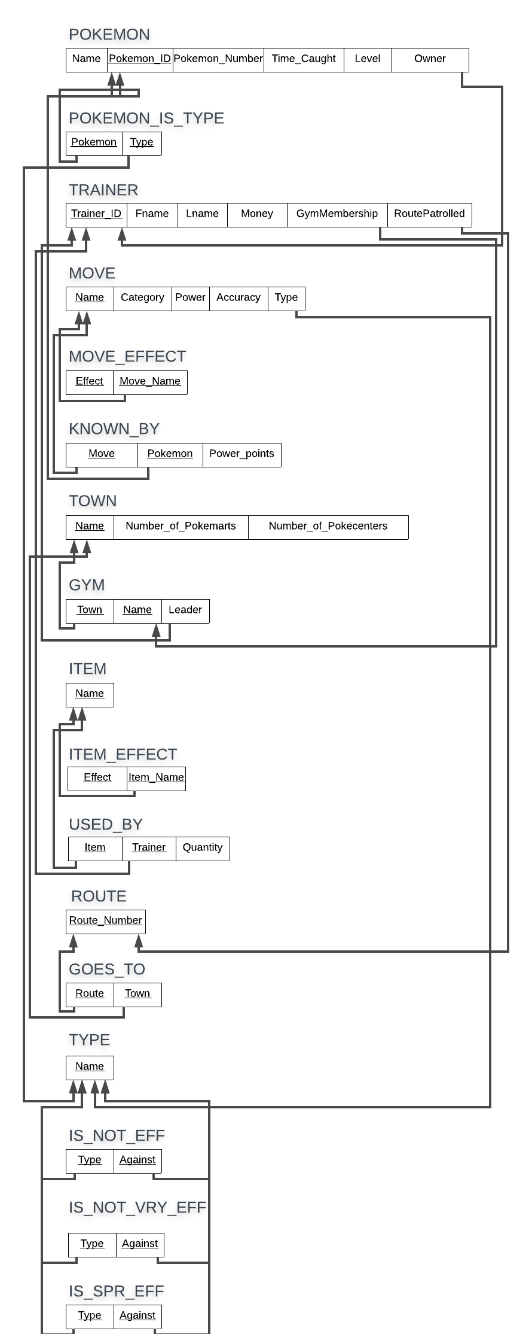

**4. Implement Database (Load.sql)**

DROP TABLE Route CASCADE CONSTRAINTS;

DROP TABLE Town CASCADE CONSTRAINTS;

DROP TABLE Trainer CASCADE CONSTRAINTS;

DROP TABLE GOES_TO CASCADE CONSTRAINTS;

DROP TABLE PType CASCADE CONSTRAINTS;

DROP TABLE Gym CASCADE CONSTRAINTS;

DROP TABLE Move CASCADE CONSTRAINTS;

DROP TABLE Move_Effect CASCADE CONSTRAINTS;

DROP TABLE Pokemon CASCADE CONSTRAINTS;

DROP TABLE Known_By CASCADE CONSTRAINTS;

DROP TABLE Item CASCADE CONSTRAINTS;

DROP TABLE Item_Effect CASCADE CONSTRAINTS;

DROP TABLE Used_By CASCADE CONSTRAINTS;

DROP TABLE IS_NOT_EFF CASCADE CONSTRAINTS;

DROP TABLE IS_NOT_VRY_EFF CASCADE CONSTRAINTS;

DROP TABLE IS_SPR_EFF CASCADE CONSTRAINTS;

DROP TABLE Pokemon_is_type CASCADE CONSTRAINTS;

CREATE TABLE Route(

route_number INT NOT NULL,

PRIMARY KEY(route_number));

INSERT INTO Route VALUES(1);

INSERT INTO Route VALUES(2);

INSERT INTO Route VALUES(3);

INSERT INTO Route VALUES(4);

INSERT INTO Route VALUES(5);

INSERT INTO Route VALUES(6);

INSERT INTO Route VALUES(7);

INSERT INTO Route VALUES(8);

INSERT INTO Route VALUES(9);

INSERT INTO Route VALUES(10);

CREATE TABLE Town (

town_name VARCHAR2(20) NOT NULL,

poke_marts INT NOT NULL,

poke_centres INT NOT NULL,

PRIMARY KEY(town_name));

INSERT INTO Town VALUES('Pallet Town', 0, 0);

INSERT INTO Town VALUES('Viridian City', 1, 1);

INSERT INTO Town VALUES('Pewter City', 1, 1);

INSERT INTO Town VALUES('Cerulean City', 1, 1);

INSERT INTO Town VALUES('Vermilion City', 1, 1);

INSERT INTO Town VALUES('Lavender Town', 1, 1);

INSERT INTO Town VALUES('Celadon City', 5, 1);

INSERT INTO Town VALUES('Fuschia City', 1, 1);

INSERT INTO Town VALUES('Cinnabar Island', 1, 1);

INSERT INTO Town VALUES('Saffron City', 1, 1);

CREATE TABLE GOES_TO(

route INT CONSTRAINT goestoroute REFERENCES Route(route_number) DISABLE,

Town VARCHAR2(20) CONSTRAINT goestotown REFERENCES TOWN(town_name) DISABLE);

INSERT INTO goes_to VALUES (1, 'Pallet Town');

INSERT INTO goes_to VALUES (1, 'Viridian City');

INSERT INTO goes_to VALUES (2, 'Viridian City');

INSERT INTO goes_to VALUES (2, 'Pewter City');

INSERT INTO goes_to VALUES (3, 'Pewter City');

INSERT INTO goes_to VALUES (3, 'Cerulean City');

INSERT INTO goes_to VALUES (3, 'Vermilion City');

CREATE TABLE PType

(name VARCHAR(20) NOT NULL,

PRIMARY KEY(name));

INSERT INTO PType VALUES ('Normal');

INSERT INTO PType VALUES ('Fire');

INSERT INTO PType VALUES ('Fighting');

INSERT INTO PType VALUES ('Water');

INSERT INTO PType VALUES ('Flying');

INSERT INTO PType VALUES ('Grass');

INSERT INTO PType VALUES ('Poison');

INSERT INTO PType VALUES ('Electric');

INSERT INTO PType VALUES ('Ground');

INSERT INTO PType VALUES ('Psychic');

INSERT INTO PType VALUES ('Rock');

INSERT INTO PType VALUES ('Ice');

INSERT INTO PType VALUES ('Bug');

INSERT INTO PType VALUES ('Dragon');

INSERT INTO PType VALUES ('Ghost');

INSERT INTO PType VALUES ('Dark');

INSERT INTO PType VALUES ('Steel');

INSERT INTO PType VALUES ('Fairy');

CREATE TABLE TRAINER

( trainerID int PRIMARY KEY,

fname varchar2(20) NOT NULL,

lname varchar2(20),

money INT NOT NULL);

INSERT INTO trainer VALUES (001, 'Ash', 'Ketchum', 2);

INSERT INTO trainer VALUES (002, 'Gary', 'Oak', 168);

INSERT INTO trainer VALUES (003, 'Jesse', 'Rocket', 50);

INSERT INTO trainer VALUES (004, 'Giovanni', NULL, 1000000);

INSERT INTO trainer VALUES (011, 'Brock', NULL, 150);

INSERT INTO trainer VALUES (012, 'Misty', NULL, 200);

INSERT INTO trainer VALUES (013, 'Lieutenant', 'Surge', 250);

INSERT INTO trainer VALUES (014, 'Erika', NULL, 300);

INSERT INTO trainer VALUES (015, 'Koga', NULL, 350);

INSERT INTO trainer VALUES (016, 'Sabrina', NULL, 400);

INSERT INTO trainer VALUES (017, 'Blaine', NULL, 450);

CREATE TABLE Gym

(gym_name VARCHAR(20) NOT NULL,

town VARCHAR(20) NOT NULL CONSTRAINT gymtown_fk REFERENCES town(town_name) DISABLE,

leader int NOT NULL CONSTRAINT gymleader_fk REFERENCES trainer(trainerID) DISABLE,

PRIMARY KEY (gym_name, town));

INSERT INTO Gym VALUES ('Pewter Gym', 'Pewter City', 11);

INSERT INTO Gym VALUES ('Cerulean Gym', 'Cerulean City', 12);

INSERT INTO Gym VALUES ('Vermilion Gym', 'Vermilion City', 13);

INSERT INTO Gym VALUES ('Celadon Gym', 'Celadon City', 14);

INSERT INTO Gym VALUES ('Fuschia Gym', 'Fuschia City', 15);

INSERT INTO Gym VALUES ('Saffron Gym', 'Saffron City', 16);

INSERT INTO Gym VALUES ('Cinnabar Gym', 'Cinnabar Island',17);

INSERT INTO Gym VALUES ('Viridian Gym', 'Viridian City', 004);

CREATE TABLE Move

(name VARCHAR2(20) NOT NULL,

category VARCHAR2(20) NOT NULL,

power INT,

accuracy INT,

type VARCHAR(20) NOT NULL CONSTRAINT movetype_fk REFERENCES PType(name) DISABLE,

PRIMARY KEY(name),

CONSTRAINT category_check CHECK (category IN ('physical', 'special', 'status')));

INSERT INTO Move VALUES ('Bind', 'physical', 15, 85, 'Normal');

INSERT INTO Move VALUES ('Ember', 'special', 40, 100, 'Fire');

INSERT INTO Move VALUES ('Counter', 'physical', NULL, 100, 'Fighting');

INSERT INTO Move VALUES ('Bubble Beam', 'special', 65, 100, 'Water');

INSERT INTO Move VALUES ('Drill Peck', 'physical', 80, 100, 'Flying');

INSERT INTO Move VALUES ('Absorb', 'special', 20, 100, 'Grass');

INSERT INTO Move VALUES ('Acid', 'special', 40, 100, 'Poison');

INSERT INTO Move VALUES ('Thunder Punch', 'physical', 75, 100, 'Electric');

INSERT INTO Move VALUES ('Bone Club', 'physical', 65, 85, 'Ground');

INSERT INTO Move VALUES ('Amnesia', 'status', NULL, NULL, 'Psychic');

INSERT INTO Move VALUES ('Rock Slide', 'physical', 75, 90, 'Rock');

INSERT INTO Move VALUES ('Ice Beam', 'special', 90, 100, 'Ice');

INSERT INTO Move VALUES ('Pin Missile', 'physical', 25, 95, 'Bug');

INSERT INTO Move VALUES ('Dragon Rage', 'special', NULL, 100, 'Dragon');

INSERT INTO Move VALUES ('Lick', 'physical', 30, 100, 'Ghost');

INSERT INTO Move VALUES ('Bite', 'physical', 60, 100, 'Dark');

INSERT INTO Move VALUES ('Clamp', 'physical', 35, 85, 'Water');

CREATE TABLE Move_Effect

(effect VARCHAR2(100) NOT NULL,

move_name VARCHAR(20) NOT NULL CONSTRAINT moveeffectmove_fk REFERENCES Move(name) DISABLE,

PRIMARY KEY(effect, move_name));

INSERT INTO Move_Effect VALUES('Multi turn attack', 'Bind');

INSERT INTO Move_Effect VALUES('Chance of burning the target', 'Ember');

INSERT INTO Move_Effect VALUES('Decreased priority', 'Counter');

INSERT INTO Move_Effect VALUES('Doubled damage if user has been attacked', 'Counter');

INSERT INTO Move_Effect VALUES('Chance of lowering targets speed', 'Bubble Beam');

INSERT INTO Move_Effect VALUES('Damage done is restored to the user', 'Absorb');

INSERT INTO Move_Effect VALUES('Chance of lowering the targets defence', 'Acid');

INSERT INTO Move_Effect VALUES('Chance of paralyzing the target', 'Thunder Punch');

INSERT INTO Move_Effect VALUES('Chance of causing target to flinch', 'Bone Club');

INSERT INTO Move_Effect VALUES('Increases users Special by two stages', 'Amnesia');

INSERT INTO Move_Effect VALUES('Chance of freezing the target', 'Ice Beam');

INSERT INTO Move_Effect VALUES('Hits the target 2-5 times', 'Pin Missile');

INSERT INTO Move_Effect VALUES('Always inflicts exactly 40 damage', 'Dragon Rage');

INSERT INTO Move_Effect VALUES('Chance of paralyzing the target', 'Lick');

INSERT INTO Move_Effect VALUES('Multi turn attack', 'Clamp');

INSERT INTO Move_Effect VALUES('Traps the target', 'Clamp');

CREATE TABLE Item

(name VARCHAR(20) NOT NULL,

PRIMARY KEY(name));

INSERT INTO Item VALUES ('Antidote');

INSERT INTO Item VALUES ('Elixir');

INSERT INTO Item VALUES ('Full Heal');

INSERT INTO Item VALUES ('Poke Ball');

INSERT INTO Item VALUES ('Revive');

INSERT INTO Item VALUES ('Potion');

CREATE TABLE Item_Effect

(item_name VARCHAR2(20) NOT NULL CONSTRAINT itemeffitem REFERENCES Item(name) DISABLE,

effect VARCHAR2(100) NOT NULL,

PRIMARY KEY(effect, item_name));

INSERT INTO Item_Effect VALUES ('Antidote', 'Cures Poison Status');

INSERT INTO Item_Effect VALUES ('Elixir', 'Restores 10PP');

INSERT INTO Item_Effect VALUES ('Full Heal', 'Fully restore Pokemon HP');

INSERT INTO Item_Effect VALUES ('Poke Ball', 'Used to catch Pokemon');

INSERT INTO Item_Effect VALUES ('Revive', 'Recover fainted Pokemon');

INSERT INTO Item_Effect VALUES ('Potion', 'Restore portion of HP');

CREATE TABLE Used_By

(item_name VARCHAR(20) NOT NULL CONSTRAINT usedbyitem REFERENCES Item(name) DISABLE,

trainer_id INT NOT NULL CONSTRAINT usedbytrainer REFERENCES Trainer(trainerid) DISABLE,

quantity INT NOT NULL,

PRIMARY KEY(item_name, trainer_id));

INSERT INTO used_by VALUES('Antidote', 003, 2);

INSERT INTO used_by VALUES('Poke Ball', 003, 3);

INSERT INTO used_by VALUES('Revive', 003, 1);

INSERT INTO used_by VALUES('Antidote', 001, 1);

INSERT INTO used_by VALUES('Potion', 001, 4);

INSERT INTO used_by VALUES('Revive', 001, 2);

INSERT INTO used_by VALUES('Elixir', 002, 2);

INSERT INTO used_by VALUES('Antidote', 004, 10);

CREATE TABLE Pokemon

(name VARCHAR(12) NOT NULL,

pokemon_ID INT PRIMARY KEY,

Pokemon_no INT NOT NULL,

time_caught date NOT NULL,

plevel INT NOT NULL,

Owner int NOT NULL CONSTRAINT pokemonowner REFERENCES TRAINER(trainerID) DISABLE);

INSERT INTO Pokemon VALUES ('Bulbasaur', 001, 097176, TO_DATE('20180101 09:41:43', 'YYYYMMDD HH24:MI:SS'), 5, 001);

INSERT INTO Pokemon VALUES ('Charmander', 004, 002226, TO_DATE('20180102 16:41:43', 'YYYYMMDD HH24:MI:SS'), 10, 001);

INSERT INTO Pokemon VALUES ('Squirtle', 007, 000337, TO_DATE('20180105 18:35:00', 'YYYYMMDD HH24:MI:SS'), 23, 001);

INSERT INTO Pokemon VALUES ('Caterpie', 010, 038227, TO_DATE('20180107 01:00:43', 'YYYYMMDD HH24:MI:SS'), 75, 001);

INSERT INTO Pokemon VALUES ('Pidgey', 016, 066729, TO_DATE('20180204 10:41:59', 'YYYYMMDD HH24:MI:SS'), 100, 002);

INSERT INTO Pokemon VALUES ('Rattata', 019, 087433, TO_DATE('20180505 11:07:43', 'YYYYMMDD HH24:MI:SS'), 56, 003);

INSERT INTO Pokemon VALUES ('Ekans', 023, 028189, TO_DATE('20180901 12:01:40', 'YYYYMMDD HH24:MI:SS'), 78, 003);

INSERT INTO Pokemon VALUES ('Pikachu', 025, 034440, TO_DATE('20181101 19:19:19', 'YYYYMMDD HH24:MI:SS'), 79, 001);

INSERT INTO Pokemon VALUES ('Sandshrew', 027, 005559, TO_DATE('20181201 08:00:10', 'YYYYMMDD HH24:MI:SS'), 45, 011);

INSERT INTO Pokemon VALUES ('Clefairy', 035, 028548, TO_DATE('20180516 23:17:12', 'YYYYMMDD HH24:MI:SS'), 34, 016);

INSERT INTO Pokemon VALUES ('Oddish', 043, 058703, TO_DATE('20180704 13:34:43', 'YYYYMMDD HH24:MI:SS'), 23, 015);

INSERT INTO Pokemon VALUES ('Mankey', 056, 098976, TO_DATE('20180819 09:12:21', 'YYYYMMDD HH24:MI:SS'), 46, 013);

INSERT INTO Pokemon VALUES ('Abra', 063, 090279, TO_DATE('20181018 10:10:10', 'YYYYMMDD HH24:MI:SS'), 23, 014);

INSERT INTO Pokemon VALUES ('Magnemite', 081, 075832, TO_DATE('20180614 23:56:56', 'YYYYMMDD HH24:MI:SS'), 89, 013);

INSERT INTO Pokemon VALUES ('Haunter', 093, 009237, TO_DATE('20180813 18:41:43', 'YYYYMMDD HH24:MI:SS'), 21, 017);

INSERT INTO Pokemon VALUES ('Onix', 095, 094582, TO_DATE('20180426 18:41:50', 'YYYYMMDD HH24:MI:SS'), 54, 011);

INSERT INTO Pokemon VALUES ('Lapras', 131, 050809, TO_DATE('20180910 19:19:59', 'YYYYMMDD HH24:MI:SS'), 33, 012);

INSERT INTO Pokemon VALUES ('Dragonite', 149, 091346, TO_DATE('20180209 15:50:39', 'YYYYMMDD HH24:MI:SS'), 67, 017);

CREATE TABLE POKEMON_IS_TYPE

(Pokemon int NOT NULL CONSTRAINT istypepokemon REFERENCES POKEMON(pokemon_ID) DISABLE ,

Type VARCHAR2(12) NOT NULL CONSTRAINT istypetype REFERENCES PTYPE(name) DISABLE);

INSERT INTO Pokemon_Is_Type VALUES (001, 'Grass');

INSERT INTO Pokemon_Is_Type VALUES (004, 'Fire');

INSERT INTO Pokemon_Is_Type VALUES (007, 'Water');

INSERT INTO Pokemon_Is_Type VALUES (010, 'Bug');

INSERT INTO Pokemon_Is_Type VALUES (016, 'Flying');

INSERT INTO Pokemon_Is_Type VALUES (019, 'Normal');

INSERT INTO Pokemon_Is_Type VALUES (023, 'Poison');

INSERT INTO Pokemon_Is_Type VALUES (025, 'Electric');

INSERT INTO Pokemon_Is_Type VALUES (027, 'Ground');

INSERT INTO Pokemon_Is_Type VALUES (035, 'Fairy');

INSERT INTO Pokemon_Is_Type VALUES (043, 'Grass');

INSERT INTO Pokemon_Is_Type VALUES (056, 'Fighting');

INSERT INTO Pokemon_Is_Type VALUES (063, 'Psychic');

INSERT INTO Pokemon_Is_Type VALUES (081, 'Steel');

INSERT INTO Pokemon_Is_Type VALUES (093, 'Ghost');

INSERT INTO Pokemon_Is_Type VALUES (095, 'Rock');

INSERT INTO Pokemon_Is_Type VALUES (131, 'Ice');

INSERT INTO Pokemon_Is_Type VALUES (149, 'Dragon');

CREATE TABLE Known_By

(move_name VARCHAR(20) NOT NULL CONSTRAINT knownbymovename REFERENCES Move(name) DISABLE,

pokemon_ID INT NOT NULL CONSTRAINT knownbypokemonid REFERENCES Pokemon(pokemon_ID) DISABLE,

power_points INT NOT NULL,

PRIMARY KEY(move_name, pokemon_ID));

INSERT INTO Known_By VALUES ('Ember', 004, 25);

INSERT INTO Known_By VALUES ('Counter', 004, 15);

INSERT INTO Known_By VALUES ('Lick', 004, 35);

INSERT INTO Known_By VALUES ('Absorb', 001, 35);

INSERT INTO Known_By VALUES ('Bind', 001, 20);

INSERT INTO Known_By VALUES ('Acid', 001, 35);

INSERT INTO Known_By VALUES ('Bubble Beam', 007, 20);

INSERT INTO Known_By VALUES ('Ice Beam', 007, 15);

INSERT INTO Known_By VALUES ('Lick', 007, 35);

INSERT INTO Known_By VALUES ('Pin Missile', 010, 20);

INSERT INTO Known_By VALUES ('Bite', 010, 20);

INSERT INTO Known_By VALUES ('Drill Peck', 016, 15);

INSERT INTO Known_By VALUES ('Counter', 016, 20);

INSERT INTO Known_By VALUES ('Counter', 019, 25);

INSERT INTO Known_By VALUES ('Bite', 019, 20);

INSERT INTO Known_By VALUES ('Lick', 019, 30);

INSERT INTO Known_By VALUES ('Bind', 023, 20);

INSERT INTO Known_By VALUES ('Bite', 023, 20);

INSERT INTO Known_By VALUES ('Thunder Punch', 025, 15);

INSERT INTO Known_By VALUES ('Bite', 025, 20);

INSERT INTO Known_By VALUES ('Counter', 025, 15);

INSERT INTO Known_By VALUES ('Bite', 027, 20);

INSERT INTO Known_By VALUES ('Ember', 027, 25);

INSERT INTO Known_By VALUES ('Bone Club', 027, 15);

INSERT INTO Known_By VALUES ('Bite', 035, 20);

INSERT INTO Known_By VALUES ('Amnesia', 035, 15);

INSERT INTO Known_By VALUES ('Ice Beam', 035, 15);

INSERT INTO Known_By VALUES ('Absorb', 043, 25);

INSERT INTO Known_By VALUES ('Bind', 043, 15);

INSERT INTO Known_By VALUES ('Counter', 056, 20);

INSERT INTO Known_By VALUES ('Thunder Punch', 056, 15);

INSERT INTO Known_By VALUES ('Amnesia', 063, 20);

INSERT INTO Known_By VALUES ('Lick', 063, 35);

INSERT INTO Known_By VALUES ('Counter', 081, 20);

INSERT INTO Known_By VALUES ('Thunder Punch', 081, 15);

INSERT INTO Known_By VALUES ('Lick', 093, 35);

INSERT INTO Known_By VALUES ('Amnesia', 093, 20);

INSERT INTO Known_By VALUES ('Rock Slide', 095, 15);

INSERT INTO Known_By VALUES ('Bite', 095, 20);

INSERT INTO Known_By VALUES ('Ice Beam', 131, 20);

INSERT INTO Known_By VALUES ('Bubble Beam', 131, 15);

INSERT INTO Known_By VALUES ('Dragon Rage', 149, 15);

INSERT INTO Known_By VALUES ('Counter', 149, 20);

CREATE TABLE IS_NOT_EFF

(Type VARCHAR2(12) REFERENCES PTYPE(name) NOT NULL,

Against VARCHAR2(12) REFERENCES PTYPE(name) NOT NULL);

INSERT INTO Is_Not_Eff VALUES ('Normal', 'Ghost');

INSERT INTO Is_Not_Eff VALUES ('Electric', 'Ground');

INSERT INTO Is_Not_Eff VALUES ('Fighting', 'Ghost');

INSERT INTO Is_Not_Eff VALUES ('Poison', 'Steel');

INSERT INTO Is_Not_Eff VALUES ('Ground', 'Flying');

INSERT INTO Is_Not_Eff VALUES ('Psychic', 'Dark');

INSERT INTO Is_Not_Eff VALUES ('Ghost', 'Normal');

INSERT INTO Is_Not_Eff VALUES ('Dragon', 'Fairy');

CREATE TABLE IS_NOT_VRY_EFF

(Type VARCHAR2(12) REFERENCES PTYPE(Name) NOT NULL,

Against VARCHAR2(12) REFERENCES PTYPE(Name) NOT NULL);

INSERT INTO Is_Not_Vry_Eff VALUES ('Normal', 'Rock');

INSERT INTO Is_Not_Vry_Eff VALUES ('Normal', 'Steel');

INSERT INTO Is_Not_Vry_Eff VALUES ('Fire', 'Fire');

INSERT INTO Is_Not_Vry_Eff VALUES ('Fire', 'Water');

INSERT INTO Is_Not_Vry_Eff VALUES ('Fire', 'Rock');

INSERT INTO Is_Not_Vry_Eff VALUES ('Fire', 'Dragon');

INSERT INTO Is_Not_Vry_Eff VALUES ('Water', 'Fire');

INSERT INTO Is_Not_Vry_Eff VALUES ('Water', 'Grass');

INSERT INTO Is_Not_Vry_Eff VALUES ('Water', 'Dragon');

INSERT INTO Is_Not_Vry_Eff VALUES ('Electric', 'Electric');

INSERT INTO Is_Not_Vry_Eff VALUES ('Electric', 'Grass');

INSERT INTO Is_Not_Vry_Eff VALUES ('Electric', 'Dragon');

INSERT INTO Is_Not_Vry_Eff VALUES ('Grass', 'Fire');

INSERT INTO Is_Not_Vry_Eff VALUES ('Grass', 'Grass');

INSERT INTO Is_Not_Vry_Eff VALUES ('Grass', 'Poison');

INSERT INTO Is_Not_Vry_Eff VALUES ('Grass', 'Flying');

INSERT INTO Is_Not_Vry_Eff VALUES ('Grass', 'Bug');

INSERT INTO Is_Not_Vry_Eff VALUES ('Grass', 'Dragon');

INSERT INTO Is_Not_Vry_Eff VALUES ('Grass', 'Steel');

INSERT INTO Is_Not_Vry_Eff VALUES ('Ice', 'Fire');

INSERT INTO Is_Not_Vry_Eff VALUES ('Ice', 'Water');

INSERT INTO Is_Not_Vry_Eff VALUES ('Ice', 'Ice');

INSERT INTO Is_Not_Vry_Eff VALUES ('Ice', 'Steel');

INSERT INTO Is_Not_Vry_Eff VALUES ('Fighting', 'Poison');

INSERT INTO Is_Not_Vry_Eff VALUES ('Fighting', 'Flying');

INSERT INTO Is_Not_Vry_Eff VALUES ('Fighting', 'Psychic');

INSERT INTO Is_Not_Vry_Eff VALUES ('Fighting', 'Bug');

INSERT INTO Is_Not_Vry_Eff VALUES ('Fighting', 'Fairy');

INSERT INTO Is_Not_Vry_Eff VALUES ('Poison', 'Poison');

INSERT INTO Is_Not_Vry_Eff VALUES ('Poison', 'Ground');

INSERT INTO Is_Not_Vry_Eff VALUES ('Poison', 'Rock');

INSERT INTO Is_Not_Vry_Eff VALUES ('Poison', 'Ghost');

INSERT INTO Is_Not_Vry_Eff VALUES ('Ground', 'Grass');

INSERT INTO Is_Not_Vry_Eff VALUES ('Ground', 'Bug');

INSERT INTO Is_Not_Vry_Eff VALUES ('Flying', 'Electric');

INSERT INTO Is_Not_Vry_Eff VALUES ('Flying', 'Rock');

INSERT INTO Is_Not_Vry_Eff VALUES ('Flying', 'Steel');

INSERT INTO Is_Not_Vry_Eff VALUES ('Psychic', 'Psychic');

INSERT INTO Is_Not_Vry_Eff VALUES ('Psychic', 'Steel');

INSERT INTO Is_Not_Vry_Eff VALUES ('Bug', 'Fire');

INSERT INTO Is_Not_Vry_Eff VALUES ('Bug', 'Fighting');

INSERT INTO Is_Not_Vry_Eff VALUES ('Bug', 'Poison');

INSERT INTO Is_Not_Vry_Eff VALUES ('Bug', 'Flying');

INSERT INTO Is_Not_Vry_Eff VALUES ('Bug', 'Ghost');

INSERT INTO Is_Not_Vry_Eff VALUES ('Bug', 'Steel');

INSERT INTO Is_Not_Vry_Eff VALUES ('Bug', 'Fairy');

INSERT INTO Is_Not_Vry_Eff VALUES ('Rock', 'Fighting');

INSERT INTO Is_Not_Vry_Eff VALUES ('Rock', 'Ground');

INSERT INTO Is_Not_Vry_Eff VALUES ('Rock', 'Steel');

INSERT INTO Is_Not_Vry_Eff VALUES ('Ghost', 'Dark');

INSERT INTO Is_Not_Vry_Eff VALUES ('Dragon', 'Steel');

INSERT INTO Is_Not_Vry_Eff VALUES ('Steel', 'Fire');

INSERT INTO Is_Not_Vry_Eff VALUES ('Steel', 'Water');

INSERT INTO Is_Not_Vry_Eff VALUES ('Steel', 'Electric');

INSERT INTO Is_Not_Vry_Eff VALUES ('Steel', 'Steel');

INSERT INTO Is_Not_Vry_Eff VALUES ('Fairy', 'Fire');

INSERT INTO Is_Not_Vry_Eff VALUES ('Fairy', 'Fighting');

INSERT INTO Is_Not_Vry_Eff VALUES ('Fairy', 'Steel');

CREATE TABLE IS_SPR_EFF

(Type VARCHAR2(12) REFERENCES PTYPE(Name) NOT NULL,

Against VARCHAR2(12) REFERENCES PTYPE(Name) NOT NULL);

INSERT INTO Is_Spr_Eff VALUES ('Fire', 'Grass');

INSERT INTO Is_Spr_Eff VALUES ('Fire', 'Ice');

INSERT INTO Is_Spr_Eff VALUES ('Fire', 'Bug');

INSERT INTO Is_Spr_Eff VALUES ('Fire', 'Steel');

INSERT INTO Is_Spr_Eff VALUES ('Water', 'Fire');

INSERT INTO Is_Spr_Eff VALUES ('Water', 'Ground');

INSERT INTO Is_Spr_Eff VALUES ('Water', 'Rock');

INSERT INTO Is_Spr_Eff VALUES ('Electric', 'Water');

INSERT INTO Is_Spr_Eff VALUES ('Electric', 'Flying');

INSERT INTO Is_Spr_Eff VALUES ('Grass', 'Water');

INSERT INTO Is_Spr_Eff VALUES ('Grass', 'Ground');

INSERT INTO Is_Spr_Eff VALUES ('Grass', 'Rock');

INSERT INTO Is_Spr_Eff VALUES ('Ice', 'Grass');

INSERT INTO Is_Spr_Eff VALUES ('Ice', 'Ground');

INSERT INTO Is_Spr_Eff VALUES ('Ice', 'Flying');

INSERT INTO Is_Spr_Eff VALUES ('Ice', 'Dragon');

INSERT INTO Is_Spr_Eff VALUES ('Fighting', 'Normal');

INSERT INTO Is_Spr_Eff VALUES ('Fighting', 'Ice');

INSERT INTO Is_Spr_Eff VALUES ('Fighting', 'Rock');

INSERT INTO Is_Spr_Eff VALUES ('Fighting', 'Dark');

INSERT INTO Is_Spr_Eff VALUES ('Fighting', 'Steel');

INSERT INTO Is_Spr_Eff VALUES ('Poison', 'Grass');

INSERT INTO Is_Spr_Eff VALUES ('Poison', 'Fairy');

INSERT INTO Is_Spr_Eff VALUES ('Ground', 'Fire');

INSERT INTO Is_Spr_Eff VALUES ('Ground', 'Electric');

INSERT INTO Is_Spr_Eff VALUES ('Ground', 'Poison');

INSERT INTO Is_Spr_Eff VALUES ('Ground', 'Rock');

INSERT INTO Is_Spr_Eff VALUES ('Ground', 'Steel');

INSERT INTO Is_Spr_Eff VALUES ('Flying', 'Grass');

INSERT INTO Is_Spr_Eff VALUES ('Flying', 'Fighting');

INSERT INTO Is_Spr_Eff VALUES ('Flying', 'Bug');

INSERT INTO Is_Spr_Eff VALUES ('Psychic', 'Fighting');

INSERT INTO Is_Spr_Eff VALUES ('Psychic', 'Poison');

INSERT INTO Is_Spr_Eff VALUES ('Bug', 'Grass');

INSERT INTO Is_Spr_Eff VALUES ('Bug', 'Psychic');

INSERT INTO Is_Spr_Eff VALUES ('Bug', 'Dark');

INSERT INTO Is_Spr_Eff VALUES ('Rock', 'Fire');

INSERT INTO Is_Spr_Eff VALUES ('Rock', 'Ice');

INSERT INTO Is_Spr_Eff VALUES ('Rock', 'Flying');

INSERT INTO Is_Spr_Eff VALUES ('Rock', 'Bug');

INSERT INTO Is_Spr_Eff VALUES ('Ghost', 'Psychic');

INSERT INTO Is_Spr_Eff VALUES ('Ghost', 'Ghost');

INSERT INTO Is_Spr_Eff VALUES ('Dragon', 'Dragon');

INSERT INTO Is_Spr_Eff VALUES ('Dark', 'Psychic');

INSERT INTO Is_Spr_Eff VALUES ('Dark', 'Ghost');

INSERT INTO Is_Spr_Eff VALUES ('Steel', 'Ice');

INSERT INTO Is_Spr_Eff VALUES ('Steel', 'Rock');

INSERT INTO Is_Spr_Eff VALUES ('Steel', 'Fairy');

INSERT INTO Is_Spr_Eff VALUES ('Fairy', 'Fighting');

INSERT INTO Is_Spr_Eff VALUES ('Fairy', 'Dragon');

INSERT INTO Is_Spr_Eff VALUES ('Fairy', 'Dark');

ALTER TABLE Gym ENABLE CONSTRAINT gymtown_fk;

ALTER TABLE Gym ENABLE CONSTRAINT gymleader_fk;

ALTER TABLE Move ENABLE CONSTRAINT movetype_fk;

ALTER TABLE Known_By ENABLE CONSTRAINT knownbymovename;

ALTER TABLE Known_By ENABLE CONSTRAINT knownbypokemonid;

ALTER TABLE Move_Effect ENABLE CONSTRAINT moveeffectmove_fk;

ALTER TABLE Item_Effect ENABLE CONSTRAINT itemeffitem;

ALTER TABLE Used_By ENABLE CONSTRAINT usedbyitem;

ALTER TABLE Used_By ENABLE CONSTRAINT usedbytrainer;

ALTER TABLE Pokemon ENABLE CONSTRAINT pokemonowner;

ALTER TABLE Goes_To ENABLE CONSTRAINT goestoroute;

ALTER TABLE Goes_To ENABLE CONSTRAINT goestotown;

ALTER TABLE Pokemon_Is_Type ENABLE CONSTRAINT istypepokemon;

ALTER TABLE Pokemon_Is_Type ENABLE CONSTRAINT istypetype;

**5. Teamwork Summary**

ERD:

Daniel made the necessary changes to our ERD, which everyone else signed off on.

Relational Schema and Normalisation:

We divided up our relations and normalisation similarly to how we devised them in the first assignment, frequently double-checking each others work.

Normalisation:

Pokemon Sam

Pokemon_is_type Sam

Trainer Tomo

Move Daniel

Move_Effect Daniel

Known_by Daniel

Town Brock

Gym Tomo

Item Daniel

Item_Effect Daniel

Used_by Daniel

Route Sam

Goes_to Tomo

Type Sam

Is_Not_eff Sam

Is_Not_Vry_eff Sam

Is_Spr_eff Brock

SQL Implementation:

This was done all together, with each of us creating tables and inserts one at a time until they were all done. Testing was also done collaboratively.

General:

Despite conflicting schedules, group work went smoothly on this project, and being able to spend some solid time all together in the lab at the end meant we were able to work together to iron out any errors in our implementation.